PRESS RELEASE

Maximum Retaining Force:

Over 13 N for RAST 2.5 Connectors

Schalksmühle,11 March 2016. Lumberg, as a specialist for RAST connectors in insulation displacement technology, is once again expanding its product range by the new 3517-4 model. Demands are ever-increasing, even specially formulated by the automotive industry, when it comes to retaining forces and lock on the PCB edge for direct connectors – a highly space-saving and economical solution – of RAST standard with a contact pitch of 2.5 mm. With Lumberg already grading its products by retaining force, the new 3517-4, with optional keying rib and closed sides, reaches an outstanding retaining force of ≥ 13.4 Newton. This is made possible by the reinforced locking toes inside the reliable geometry of the casing which ensure a higher mechanical retention on the printed circuit board without taking up additional casing space.
This new model from the RAST 2.5 connector range with a proven track record for cars can also mate with existing harnessing machines with single wires of a diameter ranging between 0.22 and 0.38 mm² and insulation resistance of up to a max. 1.6 mm.

Suitable for application in temperatures between -40 to +130 degrees Celsius and with a rated voltage of 32 V AC, the new additional direct connector version shows its diversity and convenience of use with small load currents of up to 4 Amps (T_{amb} 60° C). The connector comes with 2 to 9 poles and two different materials for the insulating body. Next to PBT GV of V0 flammability standard according to UL 94, there is also a glow wire resistant version (GWT 750° C) in PA of a V2 flammability rating according to UL 94. Both carry tin-plated contact springs made of bronze.

Total no. of characters incl. blanks: 1.712

The following media kit is attached to this press release:

Product Online: http://www.lumberg.com/en/products/product/3517-4

Photo 1: LUMBERG_RAST 2.5 Direct Connector 3517-4_6-poles.jpg

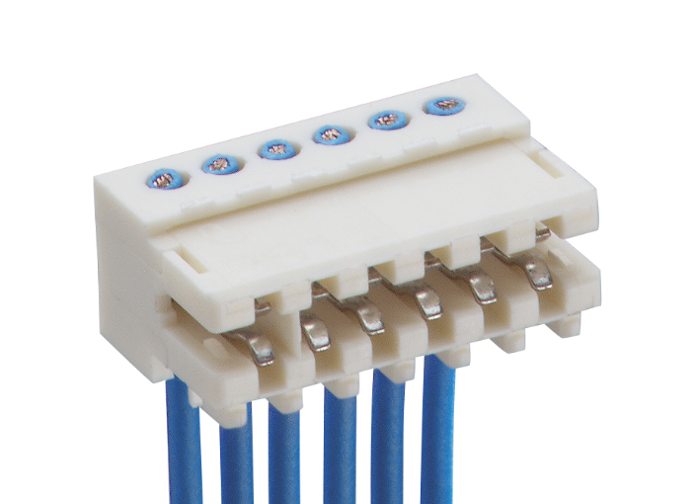

About Lumberg Group:

The Lumberg Group, headquartered in Schalksmühle, Germany, ranks among the leading providers of connector and interconnect systems. Core areas of expertise include R&D, manufacturing and the worldwide sales of electromechanical and mechatronic components. For more than 80 years now, the Group’s skills have broadened from manufacturing connectors and challenging micro-contact elements, to developing complex mechatronic assemblies, to customer-specific engineering and technical design services for all industries. In-depth application expertise led to strong partnerships in the automotive, home appliance, building technology, communications and consumer electronic industries. Family-run in the third generation, the company has a global workforce of around 1,100. Subsidiaries in Europe, America and Asia form a dense sales network. In 2014, the Group’s turnover totaled some Euro 115m. Over 20,000 catalog and customized products are proof of the company’s efficiency. www.lumberg.com

